# Exercises: Implement Hash Table with Chaining

This document defines the lab for ["Data Structures – Advanced (C#)" course @ Software University](https://softuni.bg/trainings/3113/data-structures-advanced-with-csharp-october-2020).

Please submit your solutions (**source code**) of all below described problems in [Judge](https://judge.softuni.bg/Contests/2605/05-Hash-Tables-Sets-and-Dictionaries-Lab).

You must implement a **hash table** that uses **chaining in a linked list** as collision resolution strategy:

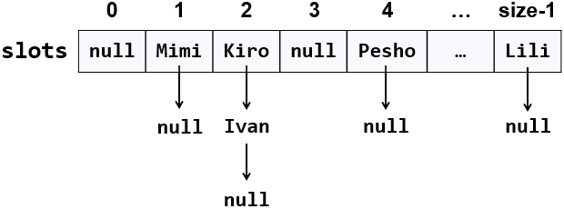

The hash table will hold its **elements** (key-value pairs) in a class **KeyValue<TKey,** **TValue>**. The hash table will consist of **slots**, each holding a **linked list of key-value pairs**: **LinkedList<KeyValue<TKey,** **TValue>>**.

## Learn about Hash Tables in Wikipedia

Before starting, get familiar with the concept of **hash table**: <https://en.wikipedia.org/wiki/Hash_table>. Note that there are many collision resolution strategies like chaining and open addressing. We will use one of the simplest strategies: **chaining** elements with collisions in a linked list.

The typical **operations** over a hash table are **add** or **replace**, **find** and **remove**. Additional operations are **enumerate all elements**, **enumerate all keys**, **enumerate all values** and **get count**. Let's start coding!

## HashTable<TKey, TValue> – Project Skeleton

You are given a **Visual Studio project skeleton** (unfinished project) holding the class **KeyValue<TKey,** **TValue>**, the unfinished class **HashTable<TKey,** **TValue>** and **unit tests** for its entire functionality. The project holds the following assets:

Your goal is to implement the missing functionality to finish the project.

First, let's look at the **KeyValue<TKey,** **TValue>** class. It holds a **key-value pair** of parameterized types **TKey** and **TValue**. To enable comparing key-value pairs, the class implements **Equals(…)** and **GetHashCode()**. It also has **ToString()** method to enable printing it on the console and view it inside the Visual Studio debugger. Note that this class is different than the .NET structure **System.Collections.Generic.KeyValuePair<TKey,** **TValue>**. First, our class is mutable (can modify the key and value), and second, it is class, not structure, so it can have a **null** value (missing value). The **KeyValue<TKey,** **TValue>** class comes out-of-the-box with the project skeleton, so you will not need to change it:

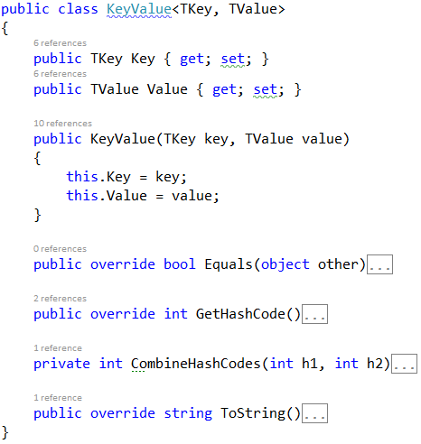

The project comes also with **unit tests** covering the entire functionality of the hash table (see the class **UnitTestsHashTable**):

## Define the Hash Table Internal Data

The first step is to define the inner **data** that holds the hash table elements:

* **LinkedList<KeyValue<TKey, TValue>>[] slots** – an array that holds the slots in the hash table
  + Each slot is either empty (**null**) or holds a **linked list** of elements with the same hash code
* **int Count** – holds the number of elements in the hash table
* **int Capacity** – holds the number of slots in the hash table
* Thus, the hash table **fill factor** can be calculated by **Count** **/** **Capacity**

The code might look like this:

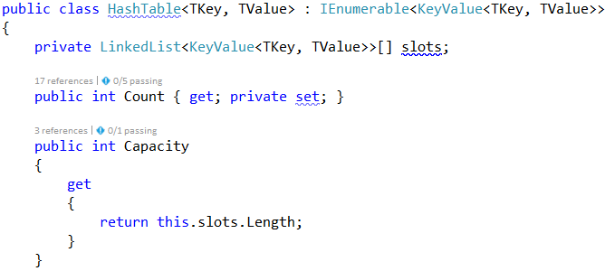

## Implement the Hash Table Constructor

Now, let's implement the hash table **constructor**. Its purpose is to allocate the slots that will hold the hash table elements. The hash table constructor has two forms:

* Parameterless constructor – should allocate 16 slots (16 is the default initial hash table capacity)
* Constructor with parameter **capacity** – allocates the specified capacity in the underlying array (slots)

The code might look like the sample below (note that we have combined the above described two constructors in a single constructor through а default parameter value). We also introduced the constant **InitialCapacity** to hold the initial hash table capacity (16 elements):

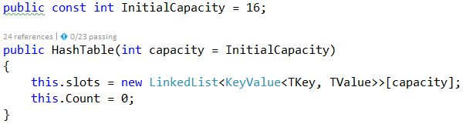

**Implement the Add(key, Value) Method**

Now, we are ready to implement the most important method **Add(key,** **value)** that inserts a new element in the hash table. It should take into account several things:

* Detect **collisions** and resolve them through **chaining** the elements in a linked list.
* Detect **duplicated keys** and throw an exception.
* **Grow** the hash table if needed (resize to double capacity when the fill factor is too high).

The **Add(key,** **value)** method might look like this:

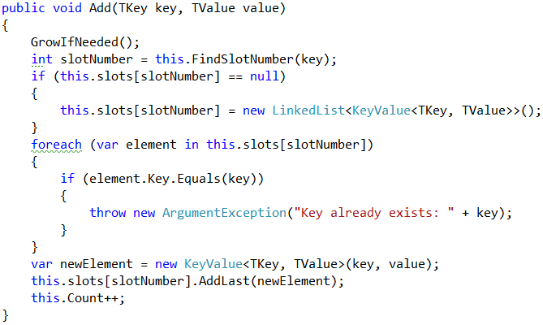

How it works? First, if the hash table is full, **grow** it (resize its capacity to 2 times bigger capacity). This will be discussed later. We can leave the **GrowIfNeeded()** method empty:

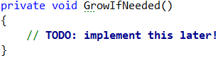

Next, **find the slot** that should hold the element to be added. The slot number is calculated by the **hash value** of the key. Typically, the **GetHashCode()** method from **System.Object** class in .NET framework provides hash codes calculation for the built-in types as well as for the custom types. It returns arbitrary 32-bit number. We need a number in the range [0 … size-1] so we take the modulus of the hash code:

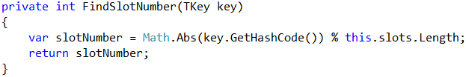

We take the absolute value because **GetHashCode()** sometimes return negative numbers.

Once we have the slot number, it is either empty (**null**) or holds a **linked list** of elements with the same hash code like the new element. In both cases, we should have in the target slot a **linked list** holding the elements with the same hash value like the **key**.

We **check for duplicated key** and throw an exception if the same key already exists. Then we **append the new element** at the end of the linked list in the target slot of the hash table and increase **this.Count**.

## Implement the Enumerator(IEnumerable<T>)

Now let's implement the enumerator: a method that passed through all elements in the hash table exactly once. In C# and .NET Framework this is achieved by implementing the **IEnumerable<T>** interface. The hash table holds key-value pairs (**KeyValue<TKey,** **TValue>**) elements, so we need to implement the interface **IEnumerable<KeyValue<TKey,** **TValue>>**. It holds two methods:

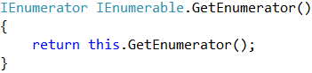

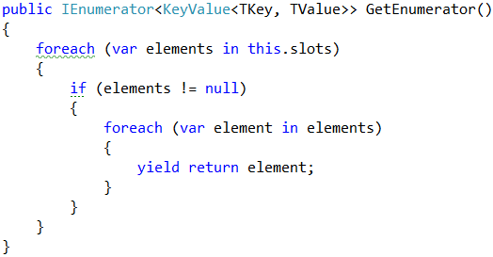

The first method calls the second. The second does the job: it **passes through all slots** and **through all elements** in the linked list in each slot and returns the elements in a sequence (as a stream). It uses the **yield** **return** construct in C# (generator function) to return the elements "on demand" upon request. Learn more about **generator functions** and **yield** **return** from Wikipedia: <https://en.wikipedia.org/wiki/Generator_(computer_programming)>.

## Implement Find(key)

Let's implement the second most important operation after adding a key-value pair – **finding an element by key**. The **Find(key)** method should either **return the element** by its key or **return** **null** if the key does not exist:

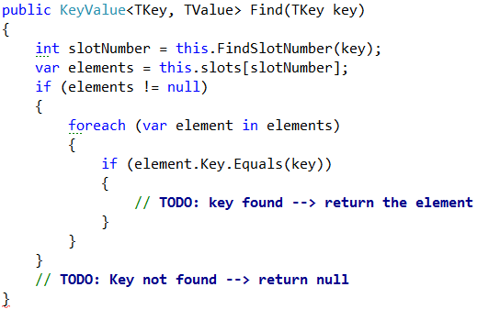

The above code works as follows:

1. **Finds the slot** holding the specified key (by calculating the hash code modulus the hash table size).
2. **Passes through all elements** **in the target slot** (in its linked list) and compare their key with the target key.

**Note**: the code is intentionally unfinished. **Fix the TODOs** yourself.

**Implement Get(key), TryGetValue(key, Out Value) and ContainsKey(key) Methods**

Once we have the **Find(key)** method, it is easy to implement the methods that directly depend on it:

* **Get(key)** – returns the element by given key or throws and exception when the key does not exist
* **TryGetValue(key,** **out** **value)** – conditional find by key
  + Returns **true** + the **value** if the ey exists in the hash table
  + Returns false if the key does not exist in the hash table
* **ContainsKey(key)** – returns whether the key exists in the hash table

Let's start with the **Get(key)** method:

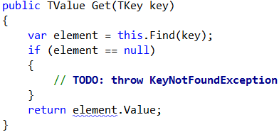

Implement the **TryGetValue(key,** **out** **value)** method in similar way:

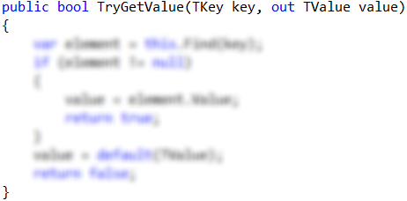

Notes:

* The code above is **intentionally blurred**. Implement it yourself!
* The method should always return a value in the **value** parameter. It is **output parameter**. The C# compiler will not allow you to leave it untouched. Use the expression **default(TValue)** when you need to return a **neutral value** of type **TValue** (**null** for classes or **0** for numbers).

The **ContainsKey(key)** method is trivial. Implement it yourself:

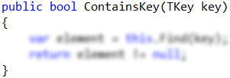

## Implement the GrowIfNeeded() and Grow() Methods

The **GrowIfNeeded()** method check whether the hash table should grow. The hash table should grow when it has filled its capacity to **more than 75%** (load factor > 75%) and we are trying to add a new element. In this case, it first calls **Grow()**, otherwise does nothing:

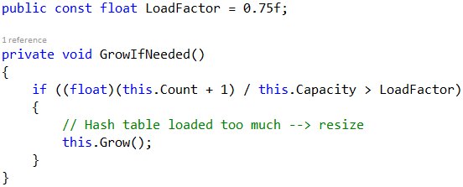

The **Grow()** method allocates a **new hash table** with **double capacity** and adds the old elements in the new hash table, then replaces the old hash table with the new one:

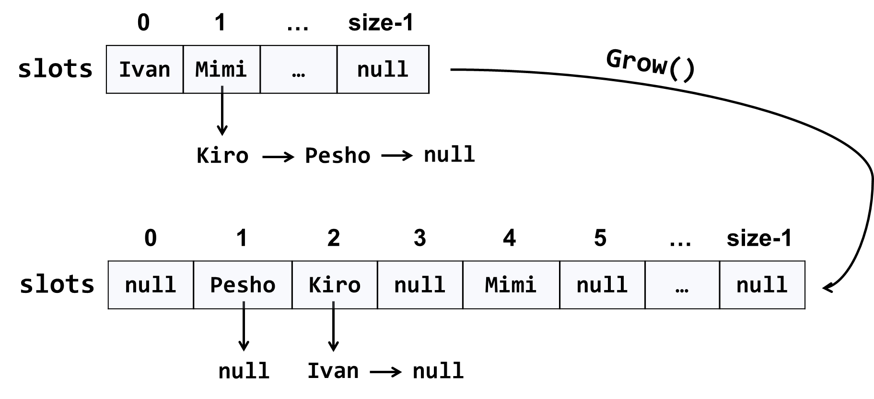

The code might look like this:

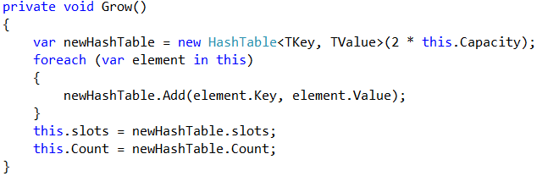

**Implement AddOrReplace(key, Value)**

The method **AddOrReplace(key,** **value)** is very similar to the **Add(key,** **value)** method. The only difference is the **Add(key,** **value)** throws and exception when the key is found to already exist in the hash table, while in the same situation **AddOrReplace(key,** **value)** replaces the **value** in the element holding the **key**, with the **new value** passed as argument.

Hint: copy / paste the code from **Add(key,** **value)** and slightly modify its logic.

Implement **AddOrReplace(key,** **value)** yourself. The code below is intentionally blurred:

**Indexer This[key]**

Now we are ready to implement the indexer **this[key]**. It is a special method that accesses the hash table indexed by key. It does two things:

* **get** by **key** – returns the **value** by given **key** or exception when the key is not found.
* **set** a **value** by **key** – adds or replace the **value** by given **key**.

We already have methods **Get(key)** and **AddOrReplace(key,** **value)**, so the indexer becomes is trivial:

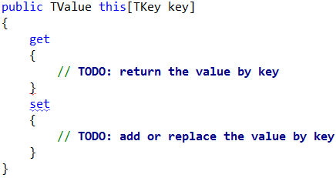

## Implement Remove(key)

The next important functionality waiting to be implemented is **removing an element by its key**. The method **Remove(key)** should either:

* Successfully **remove the element** (when the key exists) from the hash table and return **true**.
* Return **false** when the key does not exist in the hash table.

The **Remove(key)** method is not trivial. It should first **find the slot** that is expected to hold the key, then **traverse the linked list** from its first to its last element and **remove the element** is case the key is found and return **truе**. Otherwise, it should return **false**:

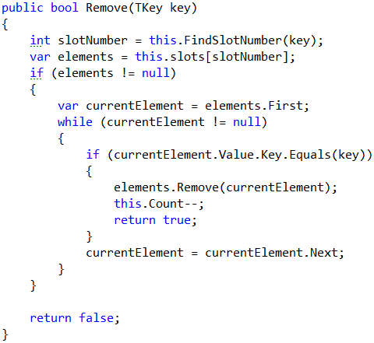

## Implement Clear()

The **Clear()** method is trivial. It should reinitialize **this.slots** and **this.Count**, like it was initially done in the hash table constructor. Implement it yourself:

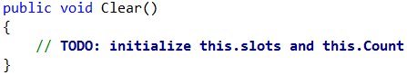

## Implement Keys and Values

Now implement the last piece of missing functionality: **enumerating all keys and values**. You can use LINQ extension method to select the keys / values from all hash table elements. We already have enumerator that returns all elements from the hash table. We just need to filter (select) the keys / values:

